Student’s name | …………………………………………………….…… | Grade | 1
Subject | Computer | Week No. | 2
Lesson Title | Need of Computers | Unit
Worksheet No. ( 2 ) (Answer)

Instruction: Match the following

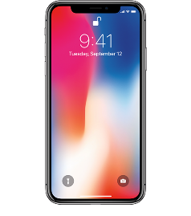 | Tablet
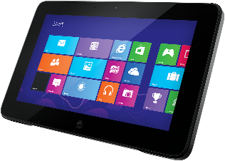 | Phone
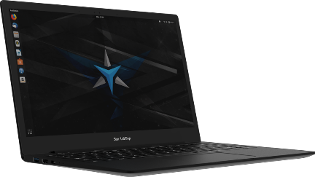 | Labtop
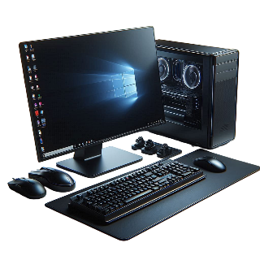 | Computer

Good Luck

